1. **Configure VPC peering in cross regions.**

**Accept the peering connection in another region**

**Exchange the CIDR in the routing tables**

**Now check the pvt address of N.virginia by ping in Ohio Region**

**N.virgina to Ohio PVT address of Ohio**

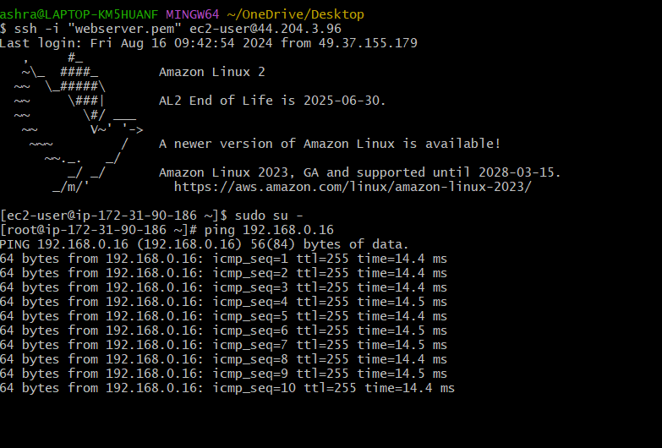

1. **Purchase one domain from godaddy.**

1. **Deploy static webiste in s3.**

1. **Create CDN and attach one SSL certificate.**

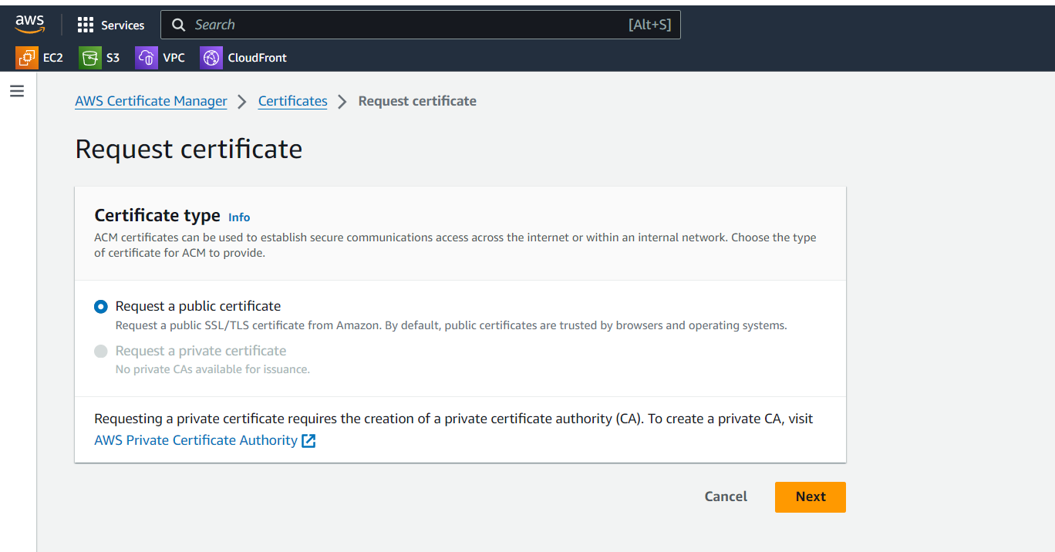

1. **Create Route53 hosted zone and MAP the domain with CDN.**

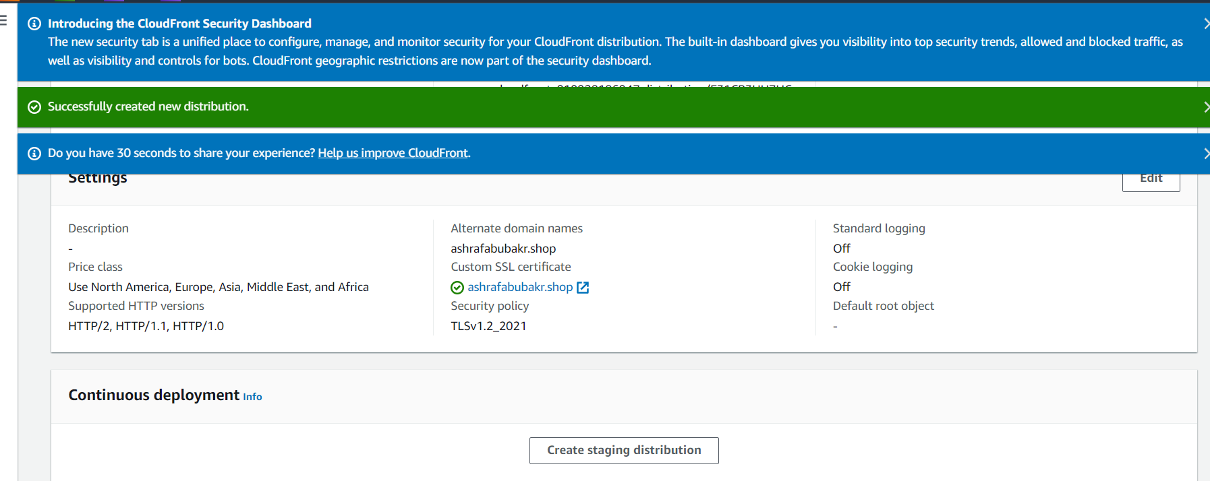

1. **Update the index.html in s3 bucket and the updated file should be accessible by using domain name.**

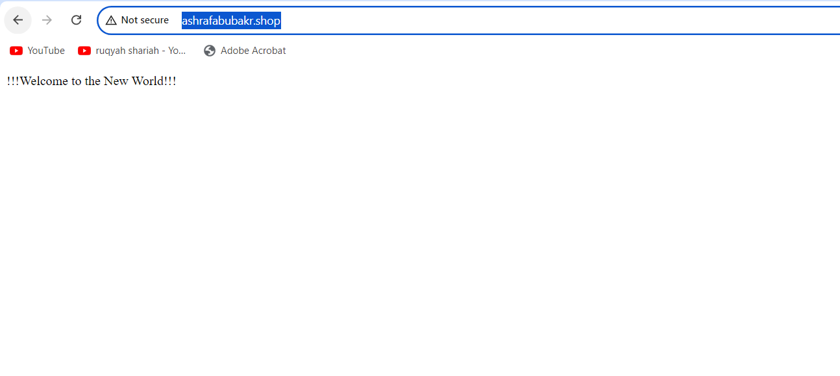

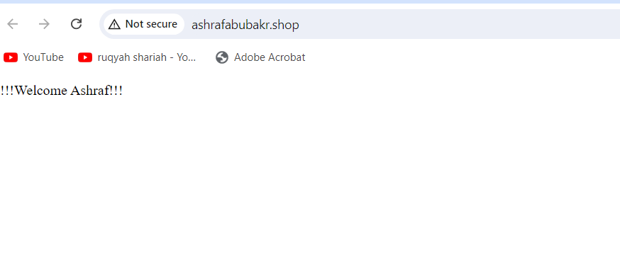

**7) Share the Domain name in slack to test the connetivity.**